Assignment 1
- The reason why the tree may be completely different with just removing one observation is that decision trees have high variance. This means that small changes in data can completely change how the generated tree becomes. Because the tree is created 'from the top down' a switch early in the process may change it radically. Tree generated with full training data:
*Second tree missing
*1.5p
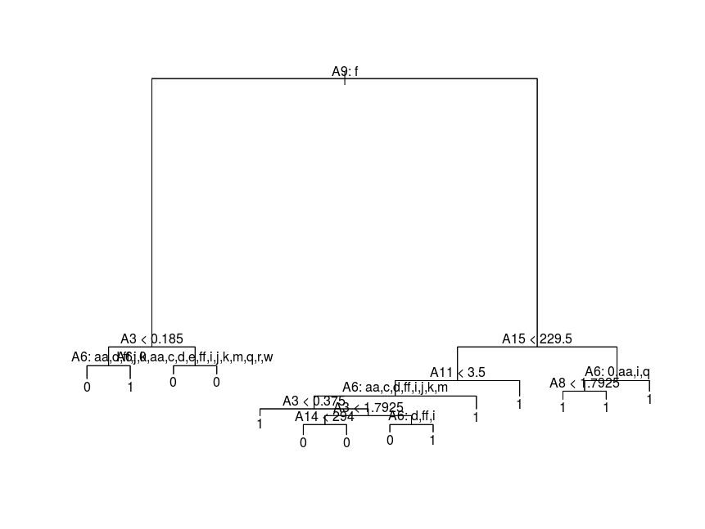
2. Performing cross-validation we can see that the lowest deviance is for the tree with 2 leaves (463.4221). Cross-validation plot of trees with different sizes: *3p

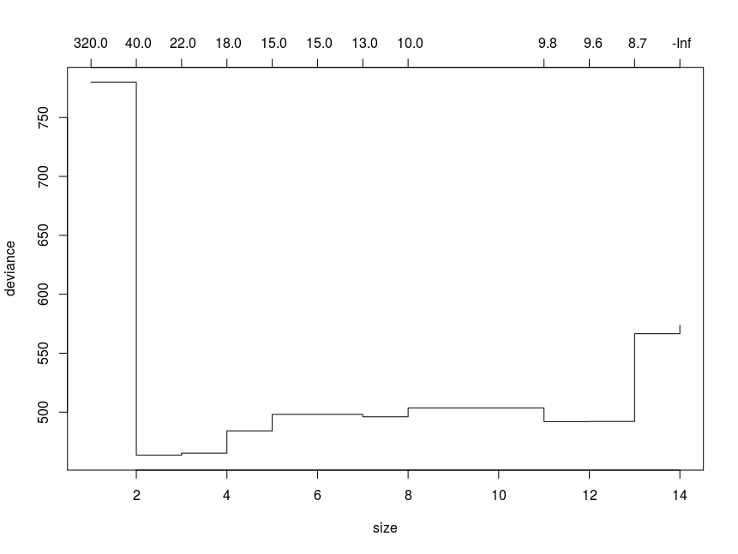
By getting the tree with 2 leaves as optimal, it means that we only use one of the original features. In this case we use A9. I don't know if this is needed, and the plot is quite blank, but I included it for safety:


3. Because most of the data is of class 1 or 0, in this case it makes sense to use the binomial distribution. We fit using glmnet with alpha = 1 for LASSO. We then perform cross-validation with cv.glmnet. The following plot is the result:
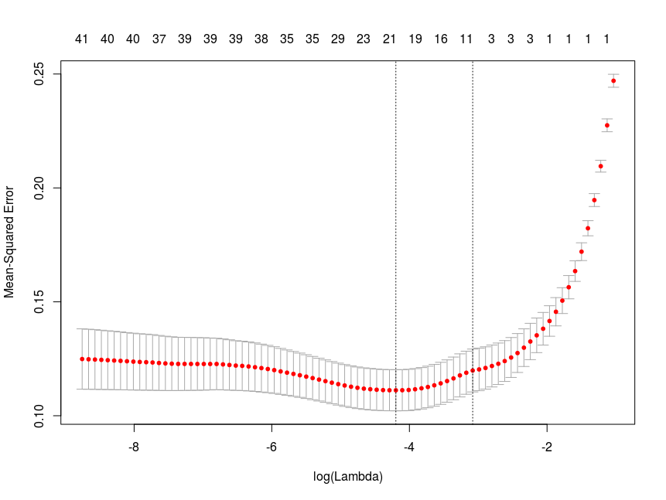
The optimal value found for lambda is 0.01504382. By using the optimal lambda value we choose a model with half of the original components (8), which seems like it could be quite a large difference from using all of them.

Looking at the plot however, we can see that although we have a global minimum at lambda = 0.015, the MSE value we obtain from that lambda and lambda = 0 are not that different (~0.115 vs ~0.125), suggesting that using all components vs using the components obtained by LASSO doesn't make a huge difference.

It is quite interesting that the optimal decision tree uses only one variable and LASSO uses 8 variables, while using 16 doesn't seem to be far from optimal in LASSO. However, looking at the LASSO plot again, we can see that we can get an MSE of ~0.145 with only 1 variable, and we know decision tree's use greedy algorithms, so it is not that peculiar. *3p

4. It is sometimes better to use a probability based loss-function because the misclassification rate simply answers whether or not the classification was correct, but the given loss formula answers how far away the guess was from being correct.

For example if a model is 55% sure that the answer is 'Yes' when the answer is 'No' we would with misclassification rate simply get a fault while the given loss function would tell us that we weren't that far from actually classifying correctly in this case. *0.5p Main result missing

Assignment 2
1. Blackboost fits a model where gradients boosting is used to optimize the loss function, and regression trees are used as learners. The plot shows us the estimated risk of hyper-parameter selection. We can see that stopping the boost early at 35 iterations, seen by the dotted line, yields the lowest mean squared error (33.70). The grey lines represent the different folds of the boost, and the black line shows the cv-weighted mean of the different folds. I attached the graph for ease of reading:1p
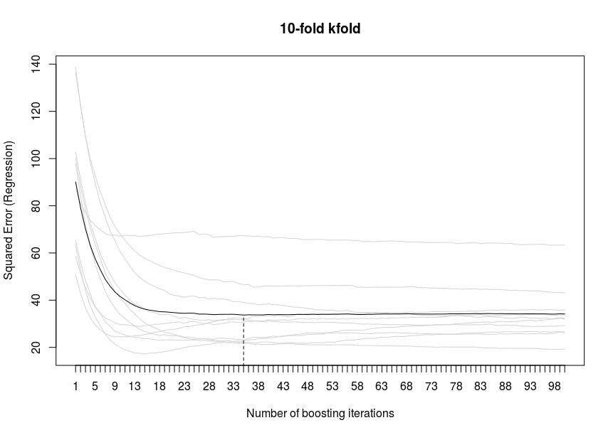

2. 3. I was supposed to leave a note in this assignment, I talked to Jose and had strange problems with the indices in R and the ksvm-function when doing the cross-validation partitioning. I was therefore supposed to only work with the data obtained in the first iteration of the cross-validation.

This is how I get my support vector machines:
svm1 = ksvm(type ~ ., data = train, kernel = "rbfdot", C = 1, kpar = list(sigma = 0.01), cross = 2)
svm2 = ksvm(type ~ ., data = train, kernel = "rbfdot", C = 5, kpar = list(sigma = 0.05), cross = 2)
svm3 = ksvm(type ~ ., data = train, kernel = "rbfdot", C = 1, kpar = list(sigma = 0.01), cross = 2)
svm4 = ksvm(type ~ ., data = train, kernel = "rbfdot", C = 5, kpar = list(sigma = 0.05), cross = 2)
svm5 = ksvm(type ~ ., data = train, kernel = "vanilladot", C = 1, cross = 2)
svm6 = ksvm(type ~ ., data = train, kernel = "vanilladot", C = 5, cross = 2)

An example of how I obtain the error for svm1:
pred1 = predict(svm1, test[,-58])

tot = 0
for (j in 1:2300) {
if (pred1[j] != test[j,58]) {
tot = tot + 1
}
}
tot = tot/2300
testScore[1,i] = tot

We can then get the lowest error model by simply doing:
min(testScore)

The errors that I received from my 6 svm's, respectively:
0.3565217
0.3360870
0.3565217
0.3360870
0.2904348
0.2926087

We can see that the linear kernel svm's perform better, with the C = 1 svm being the best one.

1.5p You cannot use the test data to select the model

4. 5. It seems from the wording in the exam that we would have access to Bishop's book (also says so in Aids: on exam title page) aswell as course slides. However we only have access to Hastie's book? Unfortunately I did not have time to find enough information in Hastie's book and implement it in R.

APPENDIX: CODE

### Assignment 1 ###

# setwd("/home/student_tilde")
# source("Ass1.R")

# install.packages("tree")

library("tree", lib.loc="/home/student_tilde/R/x86_64-pc-linux-gnu-library/3.3")

data = read.csv("given_files/tenta/crx.csv")

set.seed(12345)
n = dim(data)[1]
id = sample(1:n, floor(n*0.8))
train = data[id,]
test = data[-id,]

# 1.

fit = tree(as.factor(Class) ~ ., data = train)

train1 = train[-2,]

fit1 = tree(as.factor(Class) ~ ., data = train1)

# Trees are identical

plot(fit, main = "Full fit")
text(fit, pretty = 0)

plot(fit1, main = "Fit without 2")
text(fit1, pretty = 0)

# 2.

set.seed(12345)
cv.res = cv.tree(fit)
plot(cv.res)

# cv.res yields information about exact deviance, which is lowest for 3 leaves but also low for 4 leaves)

finalTree = prune.tree(fit, best = 2)

plot(finalTree)
text(finalTree, pretty = 0)

# 3.

x_train = model.matrix( ~ .-1, train[,-16])

X = x_train
Y = as.matrix(train$Class)

#plot(Y ~ X)

lassofit = glmnet(X, Y, alpha = 1, family = "binomial")
# family=c("gaussian","binomial","poisson","multinomial","cox","mgaussian")
plot(lassofit, xvar = "lambda")

lasso.cv = cv.glmnet(X, Y)
plot(lasso.cv)
plot(lasso.cv$lambda, lasso.cv$cvm)

# coef(lasso.cv shows 8 vars chosen)
# lasso.cv$lambda.min yields optimal value 0.01504382

# 4.

#E = sum(Y * log(p-hat)) + (1 - Y) * log(1 – p-hat)

### Assignment 2 ###

# 1.

# install.packages("mboost")

library(mboost)
bf <- read.csv2("given_files/tenta/bodyfatregression.csv")

set.seed(1234567890)
m <- blackboost(Bodyfat_percent~Waist_cm+Weight_kg, data=bf)
mstop(m)
cvf <- cv(model.weights(m), type="kfold")
cvm <- cvrisk(m, folds=cvf, grid=1:100)
plot(cvm)
mstop(cvm)

# 1. & 2.

library(kernlab)

data = read.csv("given_files/tenta/spam.csv")

#tindex <- sample(1:dim(data)[1],10)
#train <- data[-tindex, ]
#test <- data[tindex,]

errortr = matrix(ncol = 2, nrow = 6)
errorcv = matrix(ncol = 2, nrow = 6)
testScore = matrix(ncol = 2, nrow = 6)

indices = cut(seq(1:4601), breaks=2, labels=FALSE)

for (i in 1:1) {
dataIndices = which(indices == i, arr.ind=TRUE)

train = data[dataIndices,]
test = data[-dataIndices,]

svm1 = ksvm(type ~ ., data = train, kernel = "rbfdot", C = 1, kpar = list(sigma = 0.01), cross = 2)
svm2 = ksvm(type ~ ., data = train, kernel = "rbfdot", C = 5, kpar = list(sigma = 0.05), cross = 2)
svm3 = ksvm(type ~ ., data = train, kernel = "rbfdot", C = 1, kpar = list(sigma = 0.01), cross = 2)
svm4 = ksvm(type ~ ., data = train, kernel = "rbfdot", C = 5, kpar = list(sigma = 0.05), cross = 2)
svm5 = ksvm(type ~ ., data = train, kernel = "vanilladot", C = 1, cross = 2)
svm6 = ksvm(type ~ ., data = train, kernel = "vanilladot", C = 5, cross = 2)

pred1 = predict(svm1, test[,-58])
pred2 = predict(svm2, test[,-58])
pred3 = predict(svm3, test[,-58])
pred4 = predict(svm4, test[,-58])
pred5 = predict(svm5, test[,-58])
pred6 = predict(svm6, test[,-58])

tot = 0
for (j in 1:2300) {
if (pred1[j] != test[j,58]) {
tot = tot + 1
}
}
tot = tot/2300
testScore[1,i] = tot

tot = 0
for (j in 1:2300) {
if (pred2[j] != test[j,58]) {
tot = tot + 1
}
}
tot = tot/2300
testScore[2,i] = tot

tot = 0
for (j in 1:2300) {
if (pred3[j] != test[j,58]) {
tot = tot + 1
}
}
tot = tot/2300
testScore[3,i] = tot

tot = 0
for (j in 1:2300) {
if (pred4[j] != test[j,58]) {
tot = tot + 1
}
}
tot = tot/2300
testScore[4,i] = tot

tot = 0
for (j in 1:2300) {
if (pred5[j] != test[j,58]) {
tot = tot + 1
}
}
tot = tot/2300
testScore[5,i] = tot

tot = 0
for (j in 1:2300) {
if (pred6[j] != test[j,58]) {
tot = tot + 1
}
}
tot = tot/2300
testScore[6,i] = tot

}

bestmodel = min(testScore)

